# DAD 220 Database Documentation

Alexa Szlykowicz

Complete these steps as you work through the directions for Project One. Replace the bracketed text with your screenshots and brief explanations of the work they capture. Each screenshot and its explanation should be sized to approximately one quarter of the page, with the description written below the screenshot. Follow these rules for each of the prompts and questions below. Review the example document located in the Project One Supporting Materials for assistance.

## Step One: Create a Database

1. Navigate to your online integrated development environment (IDE). List and record the SQL commands that you used to complete this step here: Text

   Description automatically generated

Accessing mysql.

1. Create a database schema called QuantigrationUpdates. List out the database name. Provide the SQL commands you ran against MySQL to successfully complete this in your answer:



Showing all databases.

1. Using the entity relationship diagram (ERD) as a reference, create the following tables with the appropriate attributes and keys:
   1. A table named **Customers** in the QuantigrationUpdates database, as defined on the project ERD. Provide the SQL commands you ran against MySQL to complete this successfully in your answer:



* 1. A table named **Orders** in the QuantigrationUpdates database, as defined on the project ERD. Provide the SQL commands you ran against MySQL to complete this successfully in your answer:



* 1. A table named **RMA** in the QuantigrationUpdates database, as defined on the project ERD. Provide the SQL commands you ran against MySQL to complete this successfully in your answer:



## Step Two: Load and Query the Data

1. **Import the data from each file into tables.** 
   * Use the QuantigrationUpdates database, the three tables you created, and the three CSV files preloaded into Codio.
   * Use the import utility of your database program to load the data from each file into the table of the same name. You will perform this step three times, once for each table.



* + Text

    Description automatically generated



* + Text

    Description automatically generated with low confidence
  + 
  + Text

    Description automatically generated with low confidence

1. **Write basic queries against imported tables to organize and analyze targeted data.** For each query, replace the bracketed text with a screenshot of the query and its output. You should also include a 1- to 3-sentence description of the output.
   * Write an SQL query that returns the **count** of orders for customers located only in the city of Framingham, Massachusetts.
     1. How many records were returned?
     2. 505 records were returned.

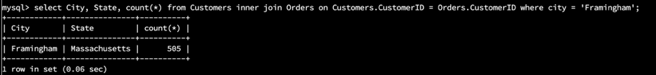

(the query is included in this screenshot)

* + Write an SQL query to **select all** of the Customers located in the state of Massachusetts.
    1. Use a WHERE clause to limit the number of records in the Customers table to only those who are located in Massachusetts.
    2. Record an answer to the following question: How many records were returned?
    3. 982 customers were returned.

(the query is included in this screenshot)

* + Write a SQL query to insert four new records into the Orders and Customers tables using the following data:

**Customers Table**

| **CustomerID** | **FirstName** | **LastName** | **StreetAddress** | **City** | **State** | **ZipCode** | **Telephone** |
| --- | --- | --- | --- | --- | --- | --- | --- |
| 100004 | Luke | Skywalker | 15 Maiden Lane | New York | NY | 10222 | 212-555-1234 |
| 100005 | Winston | Smith | 123 Sycamore Street | Greensboro | NC | 27401 | 919-555-6623 |
| 100006 | MaryAnne | Jenkins | 1 Coconut Way | Jupiter | FL | 33458 | 321-555-8907 |
| 100007 | Janet | Williams | 55 Redondo Beach Blvd | Torrence | CA | 90501 | 310-555-5678 |

Queries:









Output:

**Orders Table**

| **OrderID** | **CustomerID** | **SKU** | **Description** |
| --- | --- | --- | --- |
| 1204305 | 100004 | ADV-24-10C | Advanced Switch 10GigE Copper 24 port |
| 1204306 | 100005 | ADV-48-10F | Advanced Switch 10 GigE Copper/Fiber 44 port copper 4 port fiber |
| 1204307 | 100006 | ENT-24-10F | Enterprise Switch 10GigE SFP+ 24 Port |
| 1204308 | 100007 | ENT-48-10F | Enterprise Switch 10GigE SFP+ 48 port |

Queries:









* + In the Customers table, perform a query to count all records where the city is Woonsocket, Rhode Island.
    1. How many records are in the Customers table where the field “city” equals “Woonsocket”?

(the query is included in this screenshot)

* + In the RMA database, update a customer’s records.
    1. Write an SQL statement to select the current fields of **status** and **step** for the record in the **RMA** table with an **orderid** value of “5175.”
       1. What are the current status and step?

(the query is included in this screenshot)

* + 1. Write an SQL statement to update the **status** and **step** for the **OrderID**, 5175 to **status** = “Complete” and **step** = “Credit Customer Account.”



(this query did not give me the desired results. I did them separately instead.)



* + - 1. What are the updated **status** and **step** values for this record?

(the query is included in this screenshot)

* + Delete RMA records.
    1. Write an SQL statement to delete all records with a reason of “Rejected.”
       1. How many records were deleted?

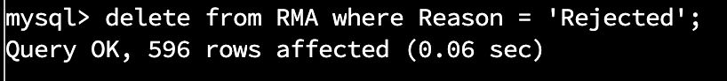

(the query is included in this screenshot)

1. **Update your existing tables** from “Customer” to “Collaborator” using SQL based on this change in requirements. Provide the SQL commands you ran against MySQL to complete this successfully in your answer:
   1. Rename all instances of “Customer” to “Collaborator.”



1. **Create an output file of the required query results.** Write an SQL statement to list the contents of the **Orders** table and send the output to a file that has a .csv extension.

